Problem: Check if a Number is a Power of 2
Objective: Write a program to check if a given integer n is a power of 2.
Definition: A number is a power of 2 if it can be expressed as 2^k where k is a non-negative integer.
Example:
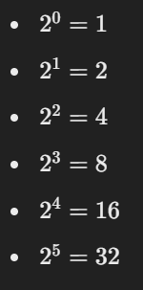
Your task: Write a function that takes an integer n as input and returns 1 (true) if n is a power of 2, and 0 (false) if it's not.

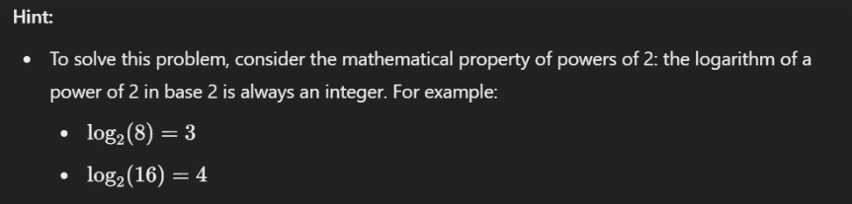
Input:
- A single integer n
Output:
- Print "n is a power of 2." if n is a power of 2.
- Print "n is not a power of 2." if n is not a power of 2.
